# ACKNOWLEDGEMENt

Every work that one completes successfully sends on the constant encouragement, good will and support of the people around. I, hereby, avail this opportunity of express my heartfelt gratitude to a number of people who extended their valuable time, full support and co operation and developing this project.

It gives me great pleasure in submitting this project entitled **“Prediction development”.**

I convey my heartfelt gratitude to my college, ―**Shantilal shah Engineering Collage”** and **“Prediction development”** for giving me this precious opportunity to work in the industry for the real time project.

I am highly indebted to **Dr. M.G.Bhatt , Principal, Shantilal Shah Engineering Collage** who had been constant source of inspiration and drive throughout the object. He has escorted me personally. I am greatly benefited by his guidance, suggestions and encouragement. 13

/

I owe the success of the project to my Project Guide, **Ms.Disha Sanghani**.**,** who was a tremendous supporter and an eager teacher, for providing excellent guidance for this project. He is one of the major sources behind the success of the project.

**There may remain some unmentioned but none unthanked…………….**

# 2.abstract

Prediction development is one type of gaming website and for entertainment. In this website user can login and perform several task that will be developed by admin. For this task user have to pay some amount of money which will be fixed by admin. Admin set some condition eg. If user win task then money will be doubled or tripled as per admin’s condition and stored in user wallet. In this website various type of category provided to user for gaming . such as , bollywood -movies, albums, song etc . , politics, serials, sports etc. Notification will be send by admin to user. In user wallet, user must have at least 100Rs.

# 3.project profile

**Project Title :** prediction development.

**Project Type :** web based application.

**Project objective :** To develop web based application.

**Technology :** PHP.

**Submitted to :**Shantilal shah engineering collage

**Purpose :** B.E(I.T) 7th sem.

**Develop by : 1.** Vaidya Trishla V.

Enrollment No: 130433116022

**2.** Shutar Pallavi R.

Enrollment No: 130433116020

**3.** Nandurbar Jigar V.

Enrollment No: 130433116013

**Team size :** 3

**Duration :** 1 year

* **Project Aim:**

The project prediction development designed and development as entertainment website. This website is one type of betting website in which we provide several categories such as sport, movies , songs ,etc .

* **Project Definition:**

The project prediction development is basically betting website which main purpose is user enjoyment.

* **Project Scope:**

Main scope of our website provide various features and categories for betting which are view by end user. System have wallet feature which is used by user. System also have administration authentication, admin can change category and subcategory, update category and subcategory. Admin also declare winner and send notification to user.

* **Modules detail:**
* **User module**
* Categories
* Subcategories
* Profile
* Login
* Contact us
* Wallet details
* Transaction details
* Categoeies
* Sports
* News
* Entertainment
* Movies
* Songs
* Election
* **Admin module**
* Admin profile
* Login
* Add categories
* Add subcategories
* Declare winner
* Send notification
* User module deal with all detail of all page and activity like view categories and subcategories and various tasks related that categories or subcategories.
* Admin module head of the system which basically deal with whole system.
* Admin mange categories and create various appropriate task. Admin also declare winner and send notification to user.

# 4. project managenent

* 1. **Project planning and scheduling:**

Projects planning and Scheduling donned through like first gathering all data and requirement of the project and then making planning for how to describe that data and how to manage that data. All required data is gathered from some existing sports, movies, song and news

related website like sports name, matches date, player name , latest movie ,latest song, latest news. Then planning is done how to describe and manage that all data which provide more benefits to all user, and provide data that should help to increase the interest of user.

* 1. **Process model : The incremental model**

We have completed our project by increments as listed below:

* **Core application:**

The basic functionalities we have approached are to analysis our project.

* **Increment 1:**

We have implemented form designing modules as our first increment.

* **Increment 2:**

Then we have expanded the user requirements to the query level by allowing him/her to fire queries on current system

* **Increment 3:**

Finally, we were toughly concentrating for the testing and validation in modules, we succeeded at the end by imposing them on**.**



**Figure 4. 1incremental model**

The Incremental model encompasses the following activities:

**1. System/information engineering and modeling :**

System engineering and analysis encompass requirements gathering at the system level with a small amount of top-level design and analysis. Information engineering encompasses requirements gathering at the strategic business level and at the business area level.

**2. Software requirements analysis**

The requirements gathering process is intensified and focused specifically on software. Software requirement analysis encompasses understanding the information domain for the software as well as required function, behavior, performance and interfacing. Requirements for both the system and the software are documented and reviewed with the customer.

**3. Design :**

Software design is actually a multi-step process that focuses on four distinct attributes of a program: data structure, software architecture, interfaces representation and procedural detail. The design process translates requirements into a representation of the software that can be accessed for quality before coding begins.

**4. Code generation**

Code-generation phase translates the design into a machine-readable form.

**5. Testing**

Once code has been generated, program testing begins. The testing process focuses on the logical internals of the software, ensuring that all statements have been tested, and on the functional externals; that is, conducting tests to uncover errors and ensure that defined input will produce actual results that agree with required results.

**6. Maintenance**

Software maintenance applies to following phases in the existing program change in software due to errors. Change in software because the software must be adapted to accommodate changes in its external environment. Change in software when the customer requires functional or performance enhancements.

# 5. system requirement study

**5.1 User characteristic:**

There are two users that dealing with the system:

1. Admin

2. User

This is user which may be technical or non-technical by nature. He/she may not be known to surfing websites and downloading etc. or may be highly sophisticated software developer too. We are to concentrate about those of non-technical ones. We are providing GUI clicks on links or buttons would make their task easier and checkbox and image-buttons which would specify the purpose of it, itself. Admin and user are responsible for maintaining database and updating in system.

5.2 **Hardware and software requirement:**

* **Hardware requirement:**
* **Processor :** i3-Processor
* **RAM :** 2.00GB
* **HDD :** 70GB
* **Software requirement:**
* **Operating system :** windows 7
* **Front-end :** PHP 5.4.12
* **Back-end :** mysql server 5.6.12
* **Web server :** wamp server

# 6. system analysis

System analysis is the process of gathering and interpreting facts, diagnosing problems and using the information to recommend improvements on the system. System analysis is a problem solving activity that requires intensive communication between the system users and system developers.

System analysis or study is an important phase of any system development process. The system is studied to the minutest detail and analyzed. The system analyst plays the role of an interrogator and dwells deep into the working of the present system. The system is viewed as a whole and the inputs to the system are identified. The outputs from the organization are traced through the various processing that the inputs phase through in the organization.

A detailed study of these processes must be made by various techniques like Interviews, Questionnaires etc. The data collected by these sources must be scrutinized to arrive to a conclusion. The conclusion is an understanding of how the system functions. This system is called the existing system. Now, the existing system is subjected to close study and the problem areas are identified. The designer now functions as a problem solver and tries to sort out the difficulties that the enterprise faces. The solutions are given as a proposal. The proposal is then weighed with the existing system analytically and the best one is selected. The proposal is presented to the user for an endorsement by the user. The proposal is reviewed on user request and suitable changes are made. This loop ends as soon as the user is satisfied with the proposal.

**6.1Weakness of existing website:**

There is only very few existing website for batting which are only for cricket. There is only one category for batting. So, user has one option for batting. It is also possible that all user are not interested in cricket or user have no knowledge of cricket but user are interested in batting.

**6.2 Requirement of new system:**

Our new system provides various categories for batting. So, user has many options for batting. There is no need of knowledge for some particular category.

**6.3 Feasibility study:**

* **Operation feasibility:**

The application is having a high degree of operational feasibility. It is also very user –friendly and even any non-technical people go though. It is providing links & menus such a ways that anyone can easily get for what one is searching for by a few clicks. It is having better adaptability & understandability.

* **Technical feasibility:**

The application provides user-friendly GUI and facility. Use language PHP. The most secure and trusted back end SQL with its advance features.

* **Schedule feasibility:**

This project has stick to its regular schedule of time v/s work to do. In order to provide quality software built, we have planned to complete project‘s schedule that makes completion of final stage earlier then demanded. This is so because we want to add additional facility or correct errors if any remains in the application at the end after being used by user and thus we can achieve robust application.

* **Economy feasibility:**

Application need the computer to have high configuration as they provide so many facilities, they consume more main memory, etc. but, both the high cost factor because of fornt end and back end of our project has most have effectiveness features and thus they are how they are told. Front end .net provide many special feature such as platform independence, compatibility with many languages, easy to built large application, etc. while SQL server is of course famous for its numerous features another user-friendly facilities.

**6.4 Technology description:**

* **PHP(Hypertext pre-processor)[Front end]:**
* PHP is an open source general-purpose, server-side scripting language originally designed for web development to produce dynamic web pages.
* It is one of the first development server sides scripting language to be embedded into an HTML source document rather than calling an external file to process date.
* The code is interpreter by a web server with a PHP processor module which generated the resulting web page.
* It is also has evolved to include a command a command line interface capability and can be used in standalone graphical application.
* PHP can be deployed on most web server and also as a standalone shell on almost every operating system and platform free of charge.
* A competitor to Microsoft’s active server page server side scrip engine and similar language, php is installed on more than 20 million web sites and 1 million web server.
* PHP was originally created by Rasumus Lerdor in 1995. The main implement of PHP is now produced by the PHP group and server as the formal reference to the PHP language.
* PHP is free software released to PHP license, which is incompatible on usage of the term PHP.
* While PHP originally stood for personal home page , it is now said to stand for PHP : Hypertext pre-processor, a recursive acronym.
* **Introduction to PHP:**
* **PHP what it is??**
* Taken directly from PHP‘s home, PHP.net, “PHP is an html-embedded scripting language.
* Much of its syntax is borrowed from c, java and Perl with a couple of unique PHP specific feature thrown in. The goal of the language is to allow web developers to write dynamically generated pages quickly.
* This is generally a good definition of PHP. However, it does contain a lot of terms you may not be used to. Another way to think of PHP is a powerful, behind the scenes scripting language that your visitor won’t see!
* When someone visits your PHP webpage, your web server processes the PHP code. It then sees which parts it needs to show to visitors (content and pictures) and hides the other stuff (file operations, math calculations, etc.) then translate your PHP into HTML. After the translation into HTML, it sends the webpage to your visitor’s web browser.
* **PHP what’s it do??**
* It is also helpful to think of PHP in terms of what it can do for you PHP will allow you to
* Reduce the time to create large websites.
* Create customized user experience for visitors based on information that you have gathered from them
* Open up thousands of possibilities for online tools. Check out PHP- Hot scripts for example of the greater things that are possible with PHP.
* Allow creation of shopping carts for e-commerce websites.
* **What do you need??**
* If your server supports PHP you don’t need to do anything.
* Just create some PHP files in your web directory, and the server will parse them for you. Because it is free, most web hosts offer PHP support.
* However, if your server does not support PHP, you must install PHP.
* **MYSQL[Back end]:**
* MY SQL is currently the most popular open source database server in existence.
* On top of that, it is very common used in conjunction with PHP script to create powerful and dynamic server-side applications.

* MY SQL has been criticized in the past for not supporting all the features of other popular and more expensive Database Management System.
* However, MY SQL continues to improve with each release (currently version 5 ) , and it has become widely popular with individuals and businesses of many different sizes.
* **What is database??**
* A database is a structure that comes in two flavours: a flat database and a relational database. A relational database is much more oriented to the human mind and is often preferred over the gabble-de-gook flat database that are just stored on hard drives like a text file. MY SQL is relational database.
* In a relational structure database there are tables that store data. The columns define which kinds of information will be stored in the table. An individual column must be created for each type of data you wish to store (i.e. Age, Weight, Height).
* On the other hand, a row contains the actual values for these specified columns. Each row will have 1 value for each and every column. For example a table with columns (Name, Age, Weight-lbs) could have a row with the values (Bob, 65, 165). If all this relational database talk is too confusing, don’t despair. We will talk about and show a few examples in the coming lessons.
* **What use a Database?**
* Database are most useful when it comes to storing information that fits into logical categories.
* For example, say that you wanted to store information of all the employees in a company. With a database you can group different parts of your business into separated tables to help store your information logically.

Example tables might be: Employees, Supervisors, and customers. Each table would then contain columns specific to these three areas. To help store information related to each employee, the employees table might Have the following columns: Hire, Date, Position, Age, and salary.

* **Java Script:**
* Java script has been around for several years now, in many different flavours. The main benefit of java script is to add addition interaction between the website and its visitors with just a little extra work by the web developer. Java script allows industrious web masters to get more out of their websites than HTML and CSS provide.
* By definition, JavaScript is a client-side scripting language. This means the web surfer’s browser will be running the script. The opposite of client-side is server-side, which occurs in a language like PHP. PHP scripts are run by the web hosting server.
* There are many uses (and abuses!) For the powerful JavaScript language. Here are a few things that you may not have seen in your web surfing days:
* Clock
* Mouse Trailer(an animation that follows your mouse when you surf a site)
* Drop Down Menus
* Alert Messages
* Popup Windows
* HTML Form Data Validation

# 7. system design

System design is the solution to the creation of a new system. This phase is composed of several systems. This phase focuses on the detailed implementation of the feasible system. It emphasis on translating design specifications to performance specification. System design has two phases of development logical and physical design.

During logical design phase the analyst describes inputs (sources), out puts (destinations), databases (data sores) and procedures (data flows) all in a format that meats the uses requirements. The analyst also specifies the user needs and at a level that virtually determines the information flow into and out of the system and the data resources. Here the logical design is done through data flow diagrams and database design.

The physical design is followed by physical design or coding. Physical design produces the working system by defining the design specifications, which tell the programmers exactly what the candidate system must do. The programmers write the necessary programs that accept input from the user, perform necessary processing on accepted data through call and produce the required report on a hard copy or display it on the screen.

**7.1 Entity Relationship Diagram (ER Diagram):**

Peter Chen develops REDs in 1976. Since then Charles Bachman and James Martin have added some slight refinement to the basic ERD principles.

* **Entity :**
* An entity is an object or concept about which you want to store information.

Entity

* **Weak Entity :**
* A weak entity is an entity that must define by a foreign key relationship with another entity as it cannot be uniquely identified by its own attributes alone.

Entity

* **Key Attribute :**
* A key attribute is the unique, distinguishing characteristic of the entity. For example, an employee’s social security number might be the employee’s key attribute.
* **Multilevel Attributes :**
* A multilevel attribute can have more than one value. For example, an employee entity can have multiple skill values.
* **Derived Attribute :**
* A derived attribute is based on another attribute. For example, an employee’s monthly salary is based on the employee’s annual salary.
* **Relationship :**
* Relationships illustrate how two entities share information in the database structure. Learn how to draw relationships first, connect the two entities, and then drop the relationship notation on the line.

Relationship

* **Cardinality :**
* Cardinality specifies how many instances of an entity relate to one instance of another entity.
* Cordiality is also closely linked to cardinality. While cardinality specifies the occurrences of a relationship, cordiality describes the relationship as either mandatory or optional. In other words, cardinality specifies the maximum number of relationship and cordiality specifies the absolute minimum number of relationships.
* **Recursive Relationship :**
* In some cases, entities can be self-linked. For example, employee’s can supervise other employee’s.

Attributes

* **ER Diagram :**

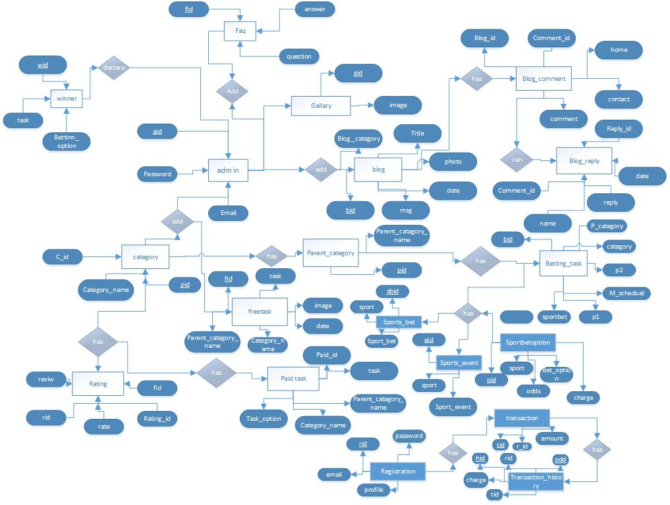

**Figure 7.1 E-R Diagram**

**7.2 Data Flow Diagram:**

* DFDs can be used to model processes that are purely physical, purely electronic, or more commonly a mix of both. Electronic data stores can be modelled via data models, particularly if they represent a relational database. Physical data stores are typically self explanatory.
* There are several common modelling rules that I follow when creating DFDs:
* All the processes must have at least one data flow in and one data flow out.
* All processes should modify the incoming data, producing new forms of outgoing data.
* Each data store must be involved with at least one data flow.
* Each external entity must be involved with a least one data flow.
* A data flow must be attached to at least one process.
* Although many traditional methods have a tendency to apply DFDs in dysfunctional ways it is still possible to do so in an agile manner as well. Keep your diagram small, as I did above. Use simple tools, such as whiteboards, to create them with your stakeholders. Travel light and erase them when you’re through with them. Create them if they’re going to add values, not simply because your process tells you to do so. The bottom line is that some of the modelling methodologies may have been flawed but the need to represent the data flow within a system is still required.
* **Data Flow Diagram Symbols:**
* **Data Flow:**

Data move in a specific direction from an origin to a destination in the form of documents, letter, telephone call, or virtually any other medium. The data flow is a ―packet of data.

* **Processes:**

In this, people, procedures, or devices that use or produce (transform) data. The physical components are not identified.

* **Source or Destination:**

External Sources or destination of data, which may be people, programs, organization or other entities interact with system but data are outside its boundary.

* **Data Store:**

Data are stored or referenced by a process in the system. The data store may represent computerized or non computerized devices. Each component in a data flow diagram is labeled with a descriptive name. Process names are further identified with a number that will be used for identification purpose. The number assign to a specific process does not represent the sequence of process. It is strictly used for identification and will take on added value to the components that make up a specific process.

**7.2.1 : Data Flow Diagram of 0 Level**

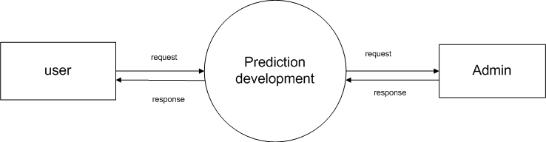

**Figure 7.2.1 Data Flow Diagram 0 level**

**7.2.2 : Data Flow Diagram 1 level of user:**



**Figure 7.2.2 Data Flow Diagram 1 level for user**

**7.2.3 : Data Flow Diagram of Admin 1 Level :**



**7.2.3 Data Flow Diagram 1 level for Admin**

**7.2.4 : Data Flow Diagram of Admin 2 level:**

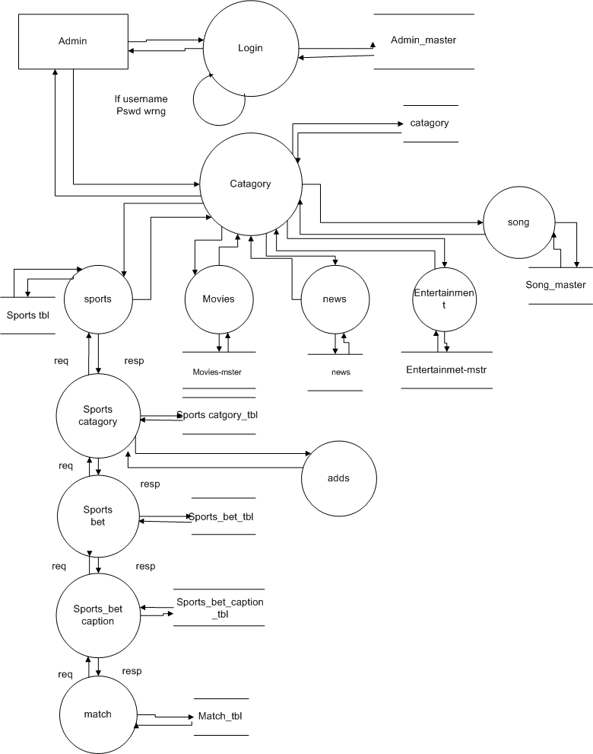

**7.2.4 Data Flow Diagram 2 level For Admin**

**7.2.5 : Data Flow Diagram of user 2 Level**



**Figure 7.2.5 Data Flow Diagram 2 level for User**

**7.3 Use case diagram:**

* **Use case :**
* A use case diagram a sequence of actions that provide something of measurable value to an actor and is drawn as a horizontal ellipse.
* **Actors :**
* An actor is a person, organization, or external system that plays a role in one or more interaction with your system. Actors are drawn as stick figures.
* **Associations :**
* Associations between actors and use cases are indicated in use case diagram by solid lines. An association exists whenever an actor is involved with an interaction described by a use case.
* Associations are modelled as lines connecting use cases and actors to one another, with an optional arrowhead on one end of the line.
* The arrowhead is often used to indicating the direction of the initial invocation of the relationship or to indicate the primary actor within use case. The arrowheads are typically confused with data flow and as a result I avoid their use.
* **System Boundary boxes (optional) :**
* You can draw a rectangle around the use cases, called the system boundary box, to indicates he scope of your system. Anything within the box represents functionality that is in scope and anything outside the box is not.
* System boundary boxes are rarely used, although on occasion I have used them to identify which are case will be delivered in each major release of a system. Fig. shows how this could be done packages (optional).

**7.3.1 Usecase diagram:**

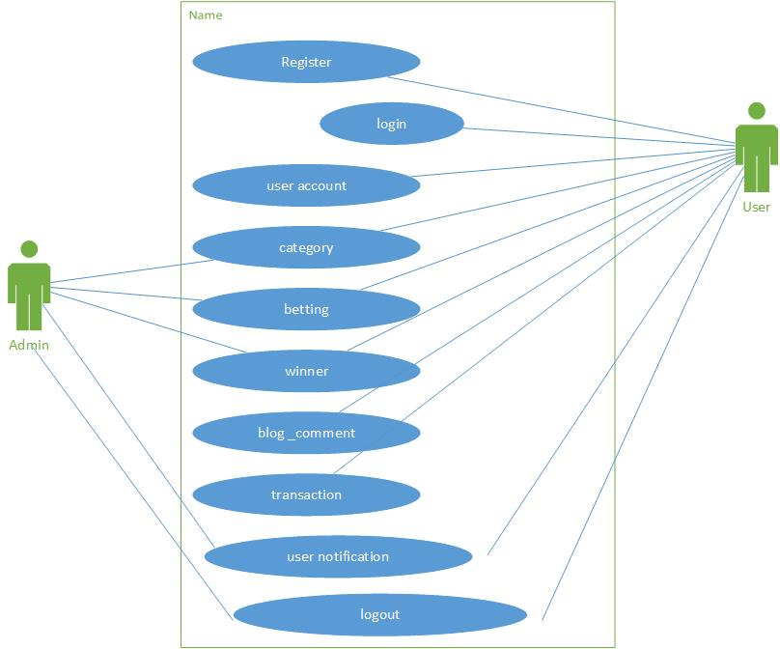

**Figure 7.3.1 Use case diagram**

**7.4 Activity diagram:**

* Activity diagram are graphical representation of workflow of stepwise activity and action with support for choice, iteration and concurrency. In the Unified Modelling Language, activity diagram can be used to describe the business and operational step-by-step workflow of components in a system. An activity diagram shows the overall flow of control.

**7.4.1 : activity Diagram of admin:**

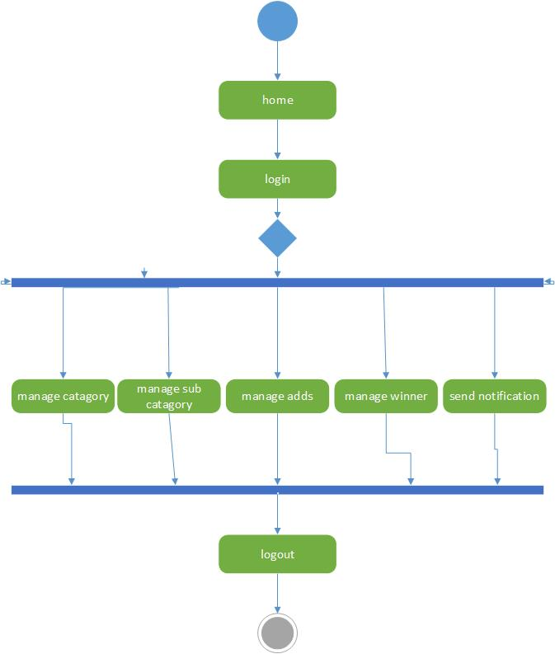

**Figure 7.4.1 Activity Diagram For Admin**

**7.4.2 : activity Diagram of user:**

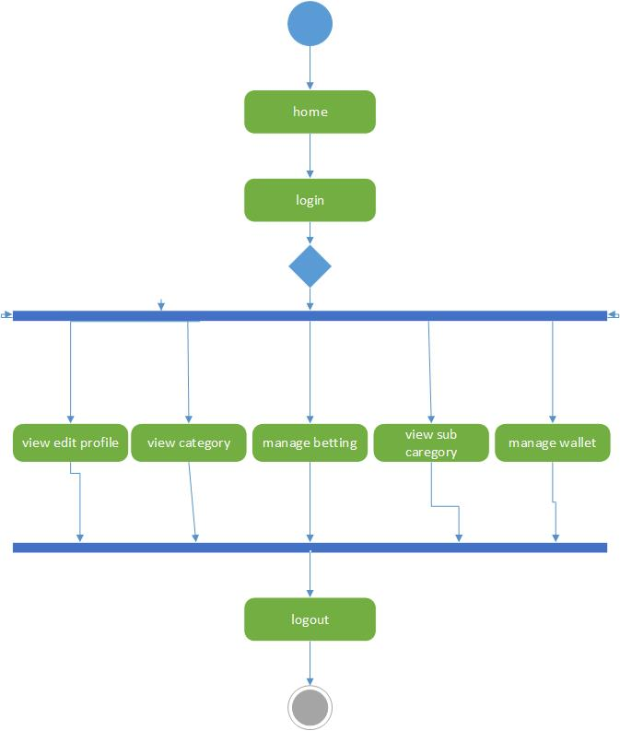

**Figure 7.4.2 Activity Diagram For User**

**7.5 Sequence diagram:**

* A sequence diagram in a Unified modeling Language (UML) is a kind of interaction diagram that shows how processes operate with one another and in what order. It is a construct of a Message Sequence Chart.
* A sequence diagram shows object interactions arranged in time sequence. It depicts the object and classes involved in the scenario and the sequence of messages exchange between the objects needed to carry out the functionality of the scenario.
* Sequence diagram typically (but not always), are associated with use case realizations in the logical view of the system under development.
* Sequence diagram are sometimes called event diagrams, event scenarios, and timing diagram.

**7.5.1 : sequence Diagram:**

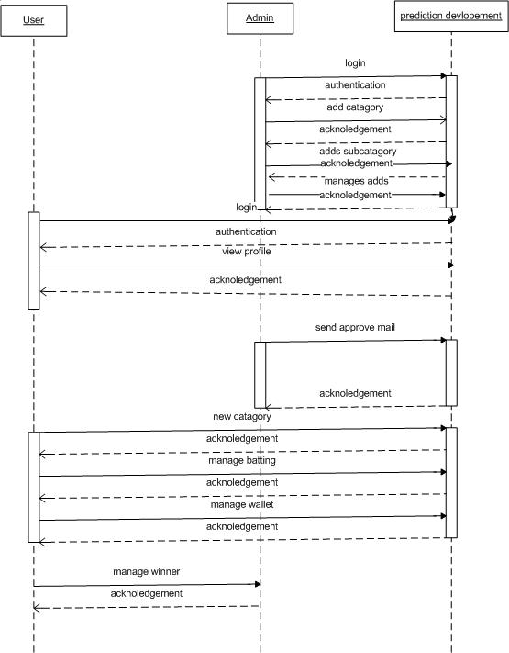

**Figure 7.5.1 Sequence Diagram**

**7.6 Data dictionary:**

**7.6.1: admin_tbl:**

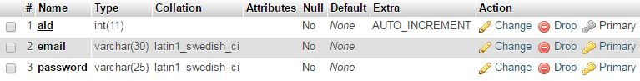

**7.6.2: betting_task_tbl:**

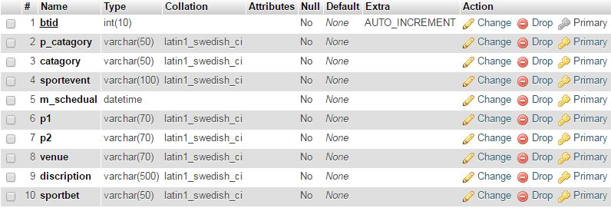

**7.6.3: Blog_tbl:**

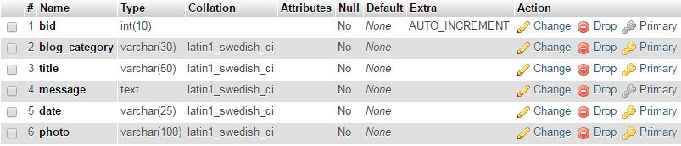

**7.6.4: blog_comment:**

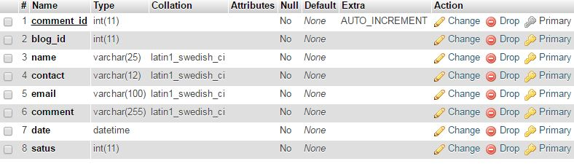

**7.6.5 Blog_reply**

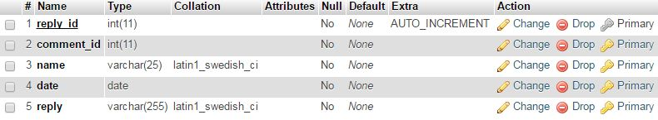

**7.6.6: category_tbl:**

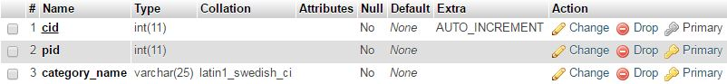

**7.6.7: contact_us_tbl:**

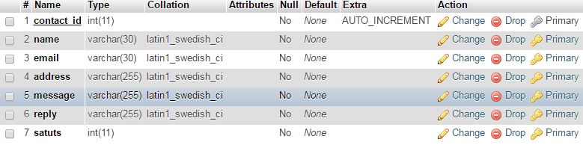

**7.6.8: faq:**

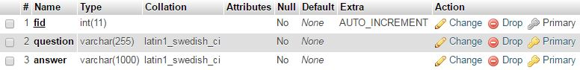

**7.6.9: free task:**

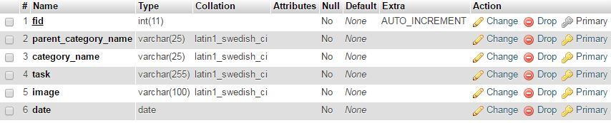

**7.6.10: gallery:**



**7.6.11: newsletter_tbl:**



**7.6.12:paid_task_tbl:**

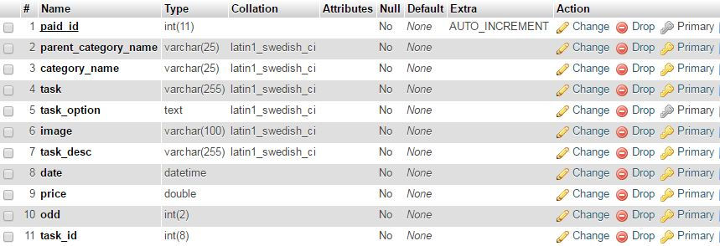

**7.6.13: parent_category:**



**7.6.14:rating_tbl:**

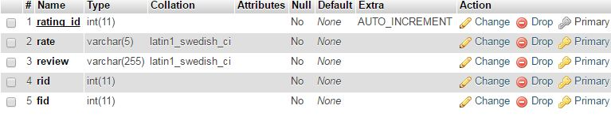

**7.6.15: registration:**

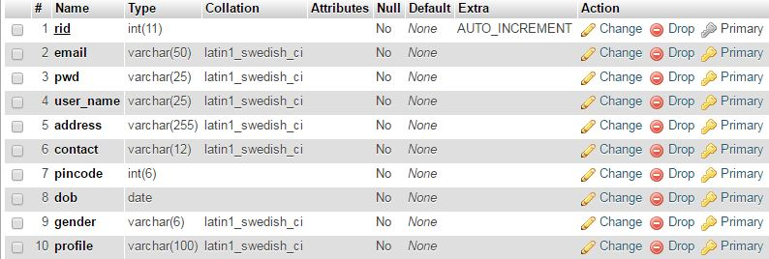

**7.6.16: sport_event_tbl:**

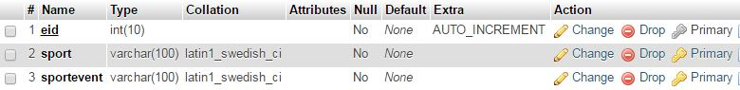

**7.6.17: sport_bet_option_tbl:**

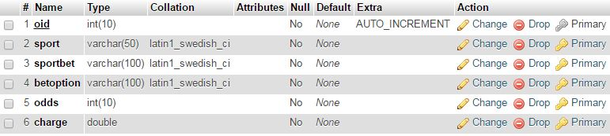

**7.6.18: transaction:**

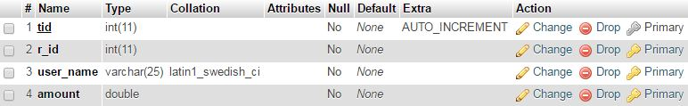

**7.6.19: transaction_history_tbl:**

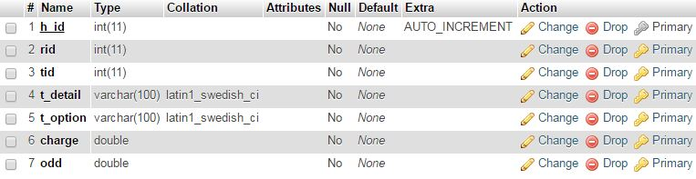

**7.6.20: winner_tbl:**

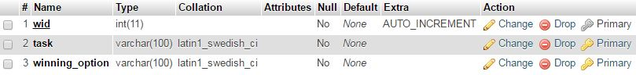

# 8. Testing

**8.1 Introduction:**

Testing is a process used to help identify the correctness, completeness and quality of developed computer software. With that in mind, testing can never completely establish the correctness of computer software.

The quality of the application can and normally does vary widely from system to system but some of the common quality attributes include reliability, stability, portability, maintainability and usability. Refer to the ISO standard ISO 9126 for a more complete list of attributes and criteria.

Testing helps is verifying and Validating if the Software is working as it is intended to be working. This involves using Static and Dynamic methodologies to Test the application.

Because of the fallibility of its human designers and its own abstract, complex nature, software development must be accompanied by quality assurance activities. It is not unusual for developers to spend 40% of the total project time on testing. For life-critical software (e.g. flight control, reactor monitoring), testing can cost 3 to 5 times as much as all other activities combined. The destructive nature of testing requires that the developer discard preconceived notions of the correctness of his/her developed software. Testing objectives includes:

1) Testing is a process of executing a program with the intent of finding an error.

2) A good test case is one that has a high probability of finding an as yet undiscovered error.

3) A successful test is one that uncovers an as yet undiscovered error.

Testing should systematically uncover different classes of errors in a minimum amount of time and with a minimum amount of effort. A secondary benefit of testing is that it demonstrates that the software appears to be working as stated in the specifications. The data collected through testing can also provide an indication of the software's reliability and quality. But, testing cannot show the absence of defect -- it can only show that software defects are present.

**8.2 White Box Testing**

The purpose of any security testing method is to ensure the robustness of a system in the face of malicious attacks or regular software failures. White box testing is performed based on the knowledge of how the system is implemented. White box testing includes analyzing data flow, control flow, information flow, coding practices, and exception and error handling within the system, to test the intended and unintended software behavior. White box testing can be performed to validate whether code implementation follows intended design, to validate implemented security functionality, and to uncover exploitable vulnerabilities.

White box testing requires access to the source code. Though white box testing can be performed any time in the life cycle after the code is developed, it is a good practice to perform white box testing during the unit testing phase.

White box testing requires knowing what makes software secure or insecure, how to think like an attacker, and how to use different testing tools and techniques. The first step in white box testing is to comprehend and analyze source code, so knowing what makes software secure is a fundamental requirement. Second, to create tests that exploit software, a tester must think like an attacker. Third, to perform testing effectively, testers need to know the different tools and techniques available for white box testing. The three requirements do not work in isolation, but together.

**8.3 Black Box Testing**

Black box testing is based on the software‘s specifications or requirements, without reference to its internal workings. Gray box testing combines white box techniques with black box input testing. This method of testing explores paths that are directly accessible from user inputs or external interfaces to the software. In a typical case, white box analysis is used to find vulnerable areas, and black box testing is then used to develop working attacks against these areas. The use of gray box techniques combines both white box and black box testing methods in a powerful way.

**8.4 Unit Testing**

Unit test case design begins after the high level design is approved by a Peer Technical Review. The unit test cases shall be designed to test the validity of the program's correctness. White box testing will be used to test the modules and procedures that support the modules. The white box testing technique *ignores* the function of the program under test and will focus only on its code and the structure of that code. To accomplish this, a Statement and Condition technique shall be used. Test case designers shall generate cases that not only cause each condition to take on all possible values at least once, but that cause each such condition to be executed at least once:

1. Each decision statement in the program shall take on a true value and a false value at least once during testing.

2. Each condition shall take on each possible outcome at least once during testing.

3. Each program shall be tested for complexity based on McCabe's measurement.

**8.5 Test Strategy:**

The first step in planning white box testing is to develop a test strategy based on risk analysis. The purpose of a test strategy is to clarify the major activities involved, key decisions made, and challenges faced in the testing effort. This includes identifying testing scope, testing techniques, coverage metrics, test environment, and test staff skill requirements. The test strategy must account for the fact that time and budget constraints prohibit testing every component of a software system and should balance test effectiveness with test efficiency based on risks to the system. The level of effectiveness necessary depends on the use of software and its consequence of failure. The higher the cost of failure for software, the more sophisticated and rigorous a testing approach must be to ensure effectiveness. Risk analysis provides the right context and information to derive a test strategy.

**8.6 Testing screen shots:**

**8.6.1 Registration:**

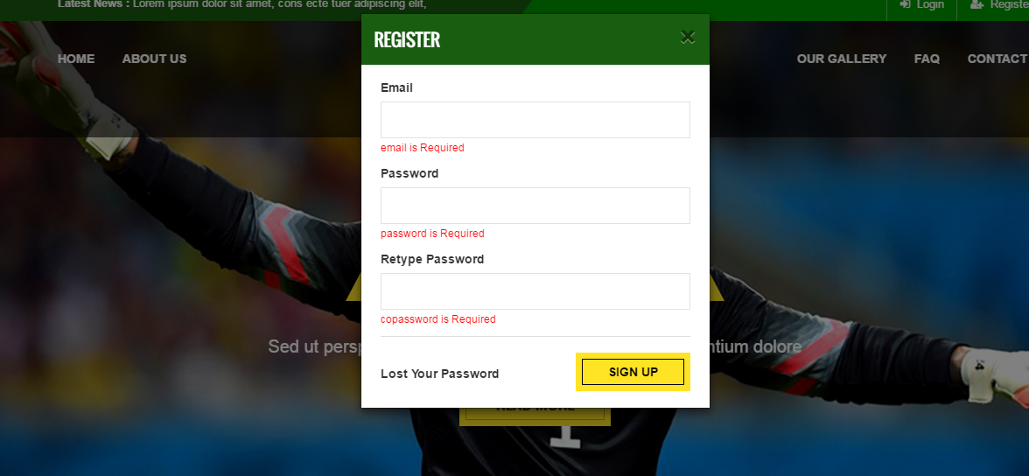

**Figure 8.6.1 Registration**

To register into the website you must be filled Email, password and Confirm password

**8.6.2 Login**

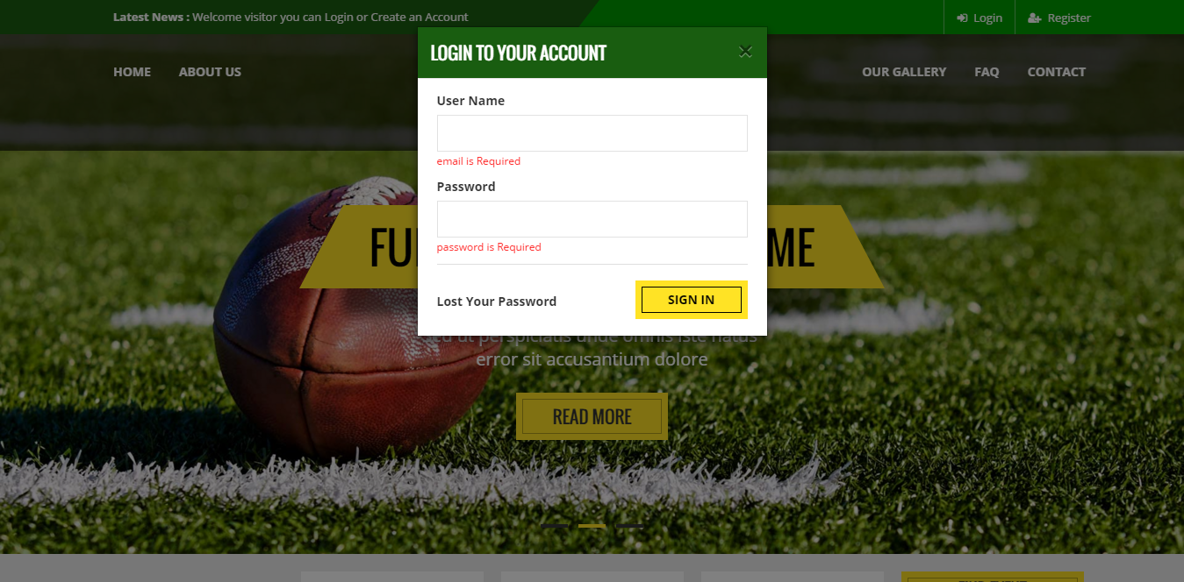

**Figure 8.6.2 Login**

To login into the website you must be enter your email id and password

**8.6.3 Registration validation**

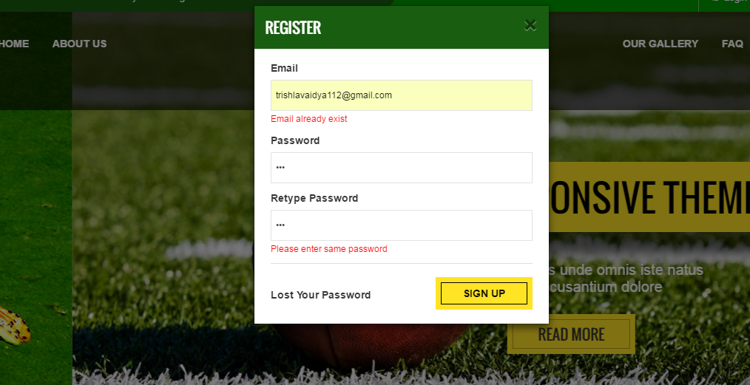

**Figure 8.6.3 Registration Validation**

Already registered email address can’t be register again.

# 9. IMPLEMENTATION

**9.1 Home Page for User:**

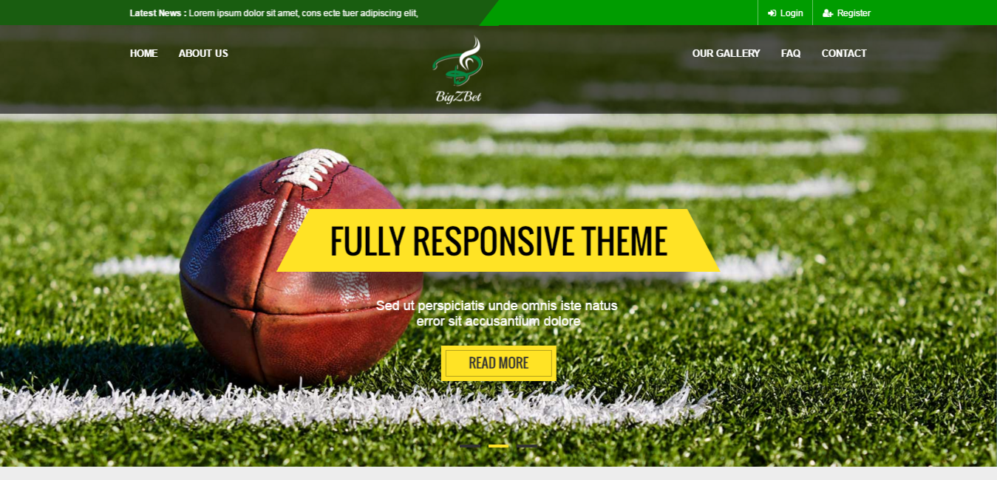

**Figure 9.1 Home page for user**

**9.2 Login page**

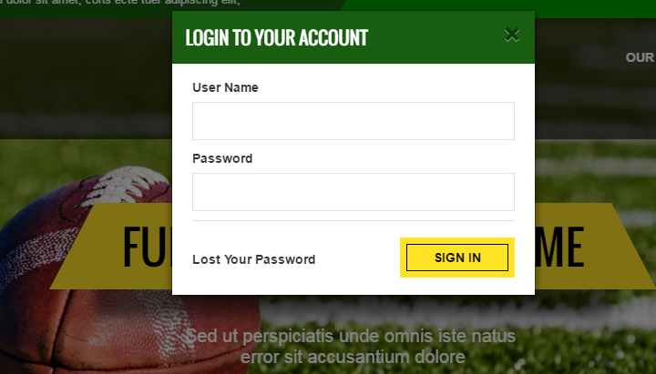

**Figure 9.2 Login page for user**

**9.3 Registration page:**

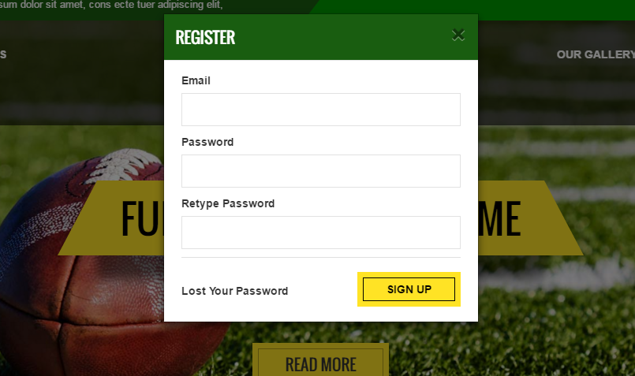

**Figure 9.3 Registration page for user**

**9.4 My account Page:**

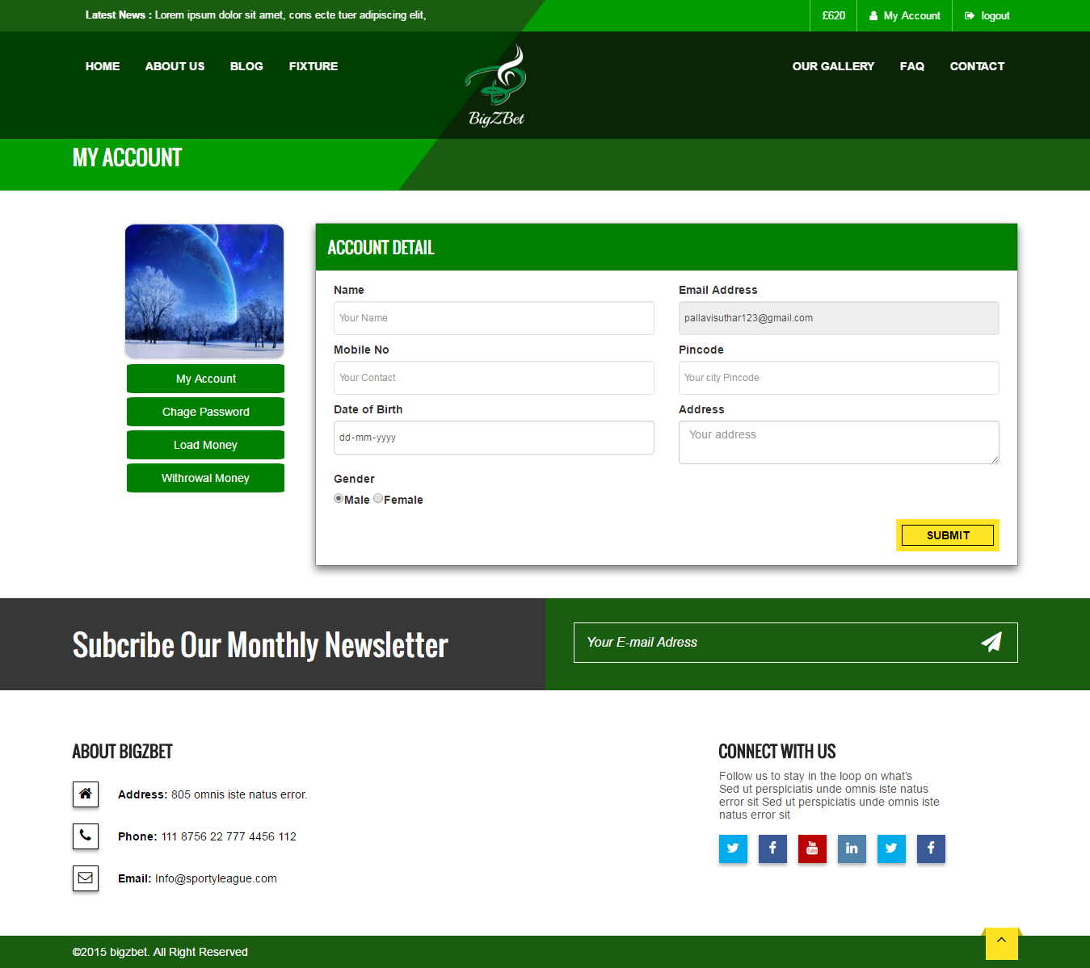

**Figure 9.4 My account page**

**9.5 Gallery Page:**

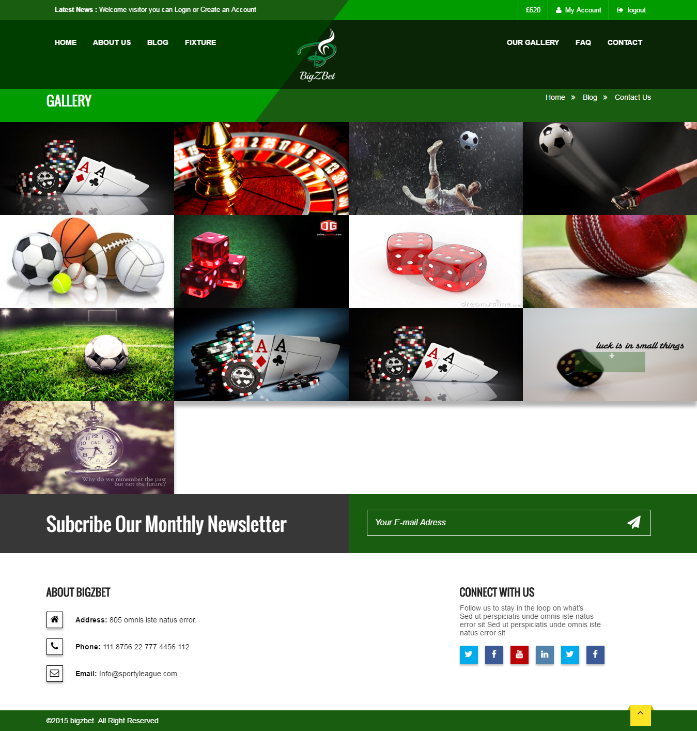

**Figure 9.5 Gallery page**

**9.6 Admin Login page:**

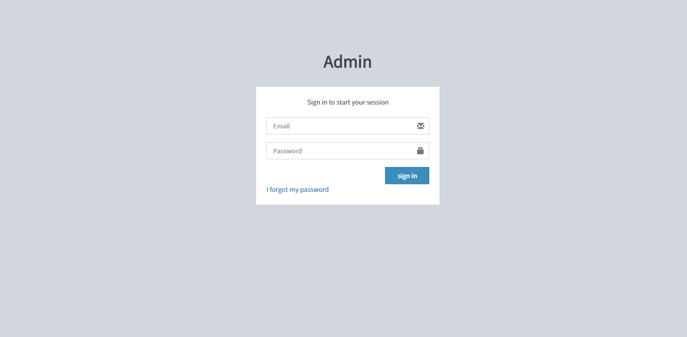

**Figure 9.6 Admin login page**

**9.7 Add New category:**

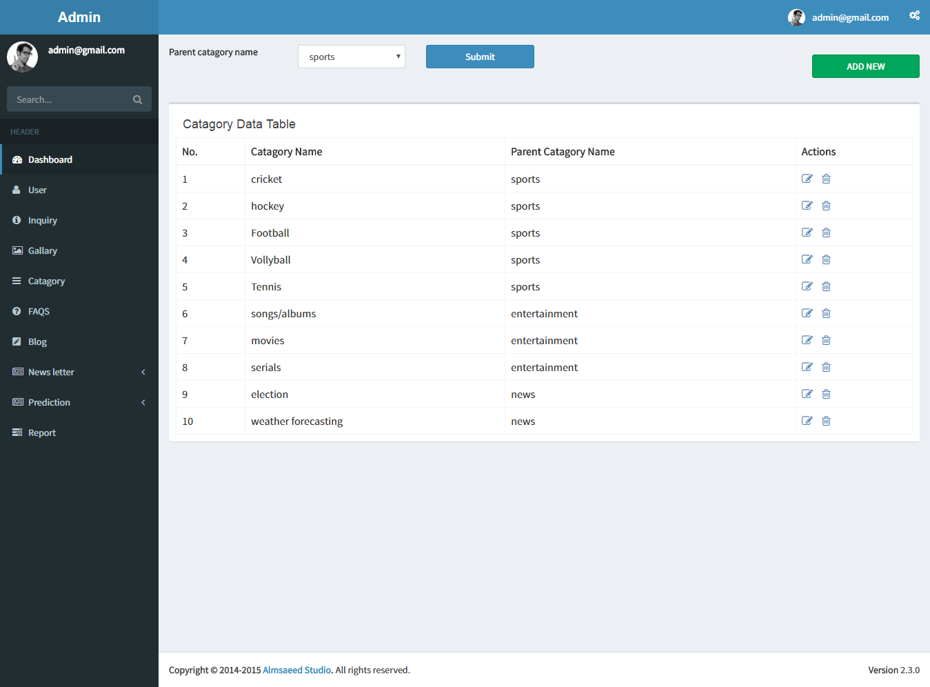

**Figure 9.7 Add new category page**

**9.8 Add Gallery:**

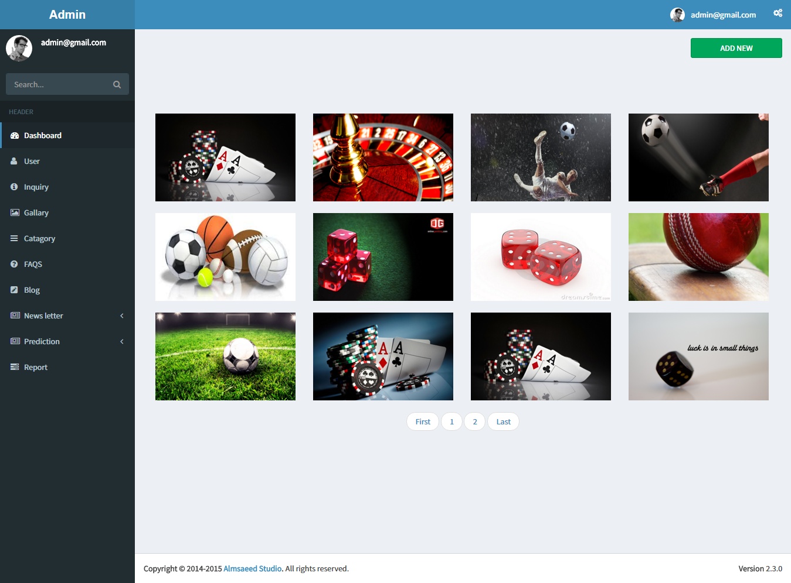

**Figure 9.8 Add Gallery page**

**9.9 Add rating:**

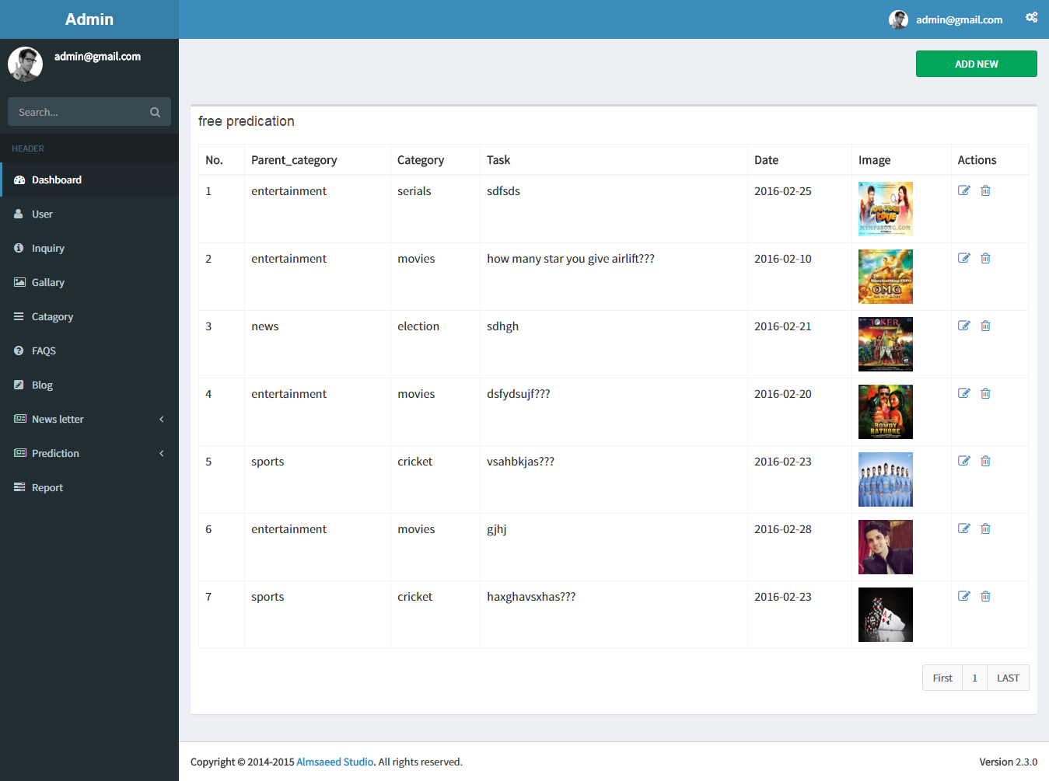

**Figure 9.9 Add rating page**

**9.10 Add Task:**

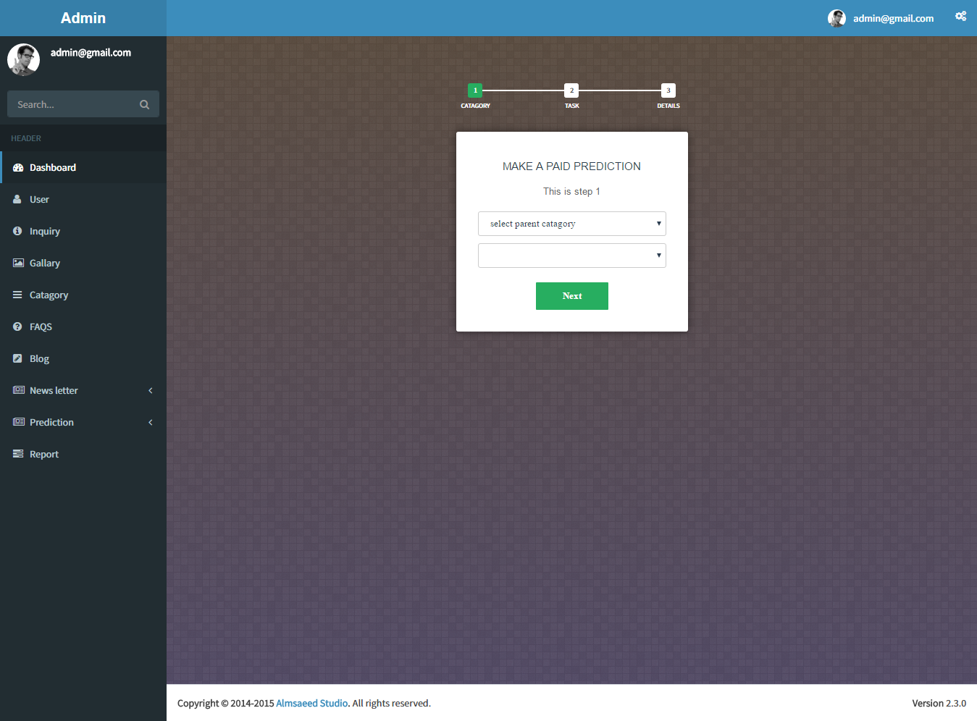

**Figure 9.10 Add task page**

# 10. LIMITATION And future scope

* **Limitation:**
* Can’t monitor all user personally.
* We can’t give all user benefit.
* If any security problem occurred user account can be hacked.
* Internet problem.
* All user are not interested in batting sometimes it’s not official.
* Sometimes user looses his/her money or time.
* **Future scope:**
* We will add e-commerce option in future.

# 11. conclusion

* In our system, we are trying our best to solve weakness of some existing website.

We add many categories for batting. We try our best to make our website user friendly. For this website user can play or can bet anywhere and anytime.

# 12. biblography

**Books:**

* Beginning PHP 5.3 - Matt doyle

**Website:**

* [www.W3scool.com](http://www.W3scool.com)
* [www.crickectfantacy.com](http://www.crickectfantacy.com)
* [www.tutorialpoint.com](http://www.tutorialpoint.com)
* [www.stackoverflow.com](http://www.stackoverflow.com)
* [www.bigzbet.com](http://www.bigzbet.com)
* [www.indiabet.com](http://www.indiabet.com)
* [www.bet365.com](http://www.bet365.com)